CSCI 4311/5311

Socket Programming

Programming Assignment 1

Due Date: Friday, October 15, 2021, 11:59 PM

**Goal of the assignment**

In this assignment, we build a simple group chat application. The protocol between the client and the server is as follows.

* You can choose to use either TCP or UDP in your implementation. (TCP preferred)
* The server is first started on a known port.
* The client program is started (server IP and port are provided on the command line).
* The client connects to the server. The server asks the user for input. The user types the username in the following format “username = ComNet” message on the terminal.
* If the user doesn’t provide a username, the server doesn’t accept the user’s messages.
* After the user enters a username, the server broadcast to everyone “Server: Welcome username”.
* After that, the user can send messages (e.g., "Hi", "Bye", "How are you"). The user's input is sent to the server via the connected socket.
* The server reads the user's input from the client's socket. If the user has typed "Bye", the server must broadcast to everyone with "Goodbye username" e.g. “Server: Goodbye ComNet”.
* If a user enters “AllUsers”, the server needs to send all active users to that user.

**Rules:**

* The server must be able to monitor and handle messages from multiple clients simultaneously. Therefore, your server needs to be multithreaded.
* Do NOT implement a peer-to-peer application. E.g., clients talk directly to each other.
* The architecture here is server-client. All messages from the clients go through the server. The server distributes the messages to all other clients who have a connection to the server.
* Implement the assignment with Java
* You need to write a report to explain your code, put some screenshots for your outputs, etc. Save your report in PDF format.
* Without the report, you don’t get any points.
* GUI is optional with 20 bonus points. If you implement the GUI version well, you will get an additional 20 points. Example:

**Step 1: Execute Server code**

e.g. java Server 8989

This starts the server listening on the port number 8989

**Step 2: Execute Client code**

java Client localhost 8989

It tells the client to connect to the server at localhost on port 8989. Then you see the following message in the server’s console:

The program asks for the username:

e.g. Enter your username:

Let say client 1 enters UNO.

Server prints “Welcome UNO”

Now, UNO can enter any message

**Step 3: Execute Client code one more time to get a new user**

The program asks for the username:

e.g. Enter your username:

Let say client 2 enters CS.

Server prints “Welcome CS”

Now, CS can enter any message

**EXAMPLE:**

Server Output:

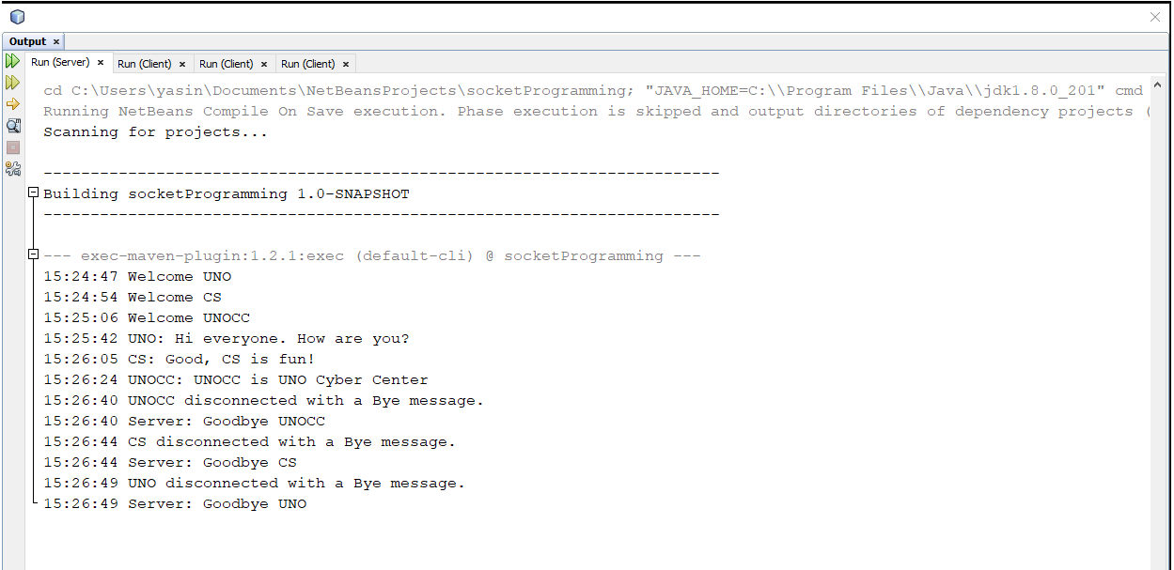

Client 1:

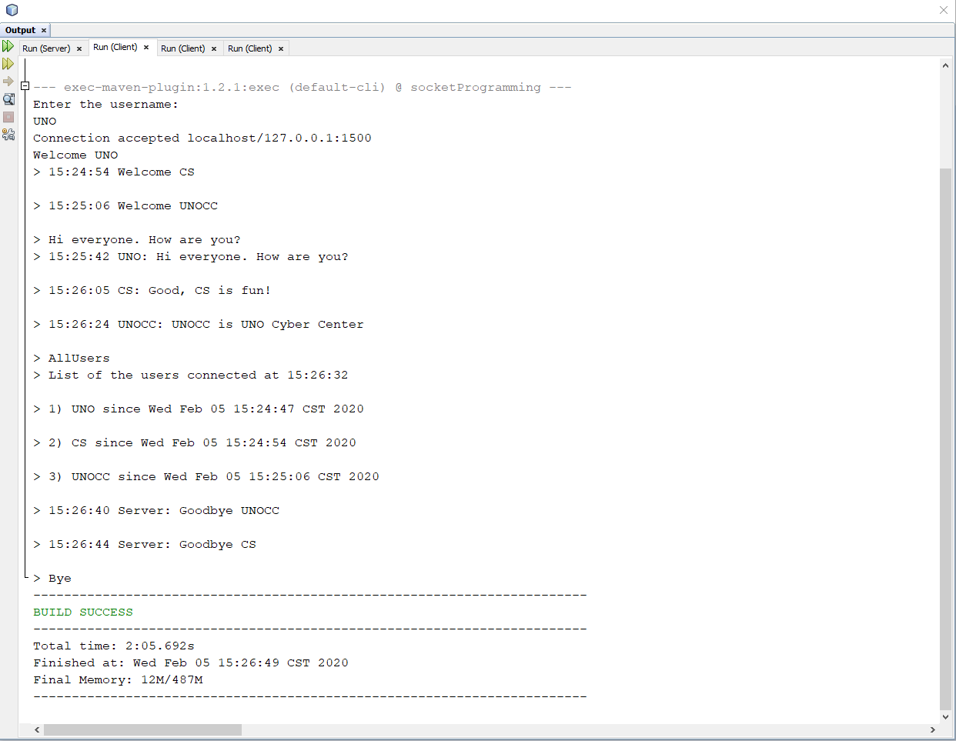

Client 2:

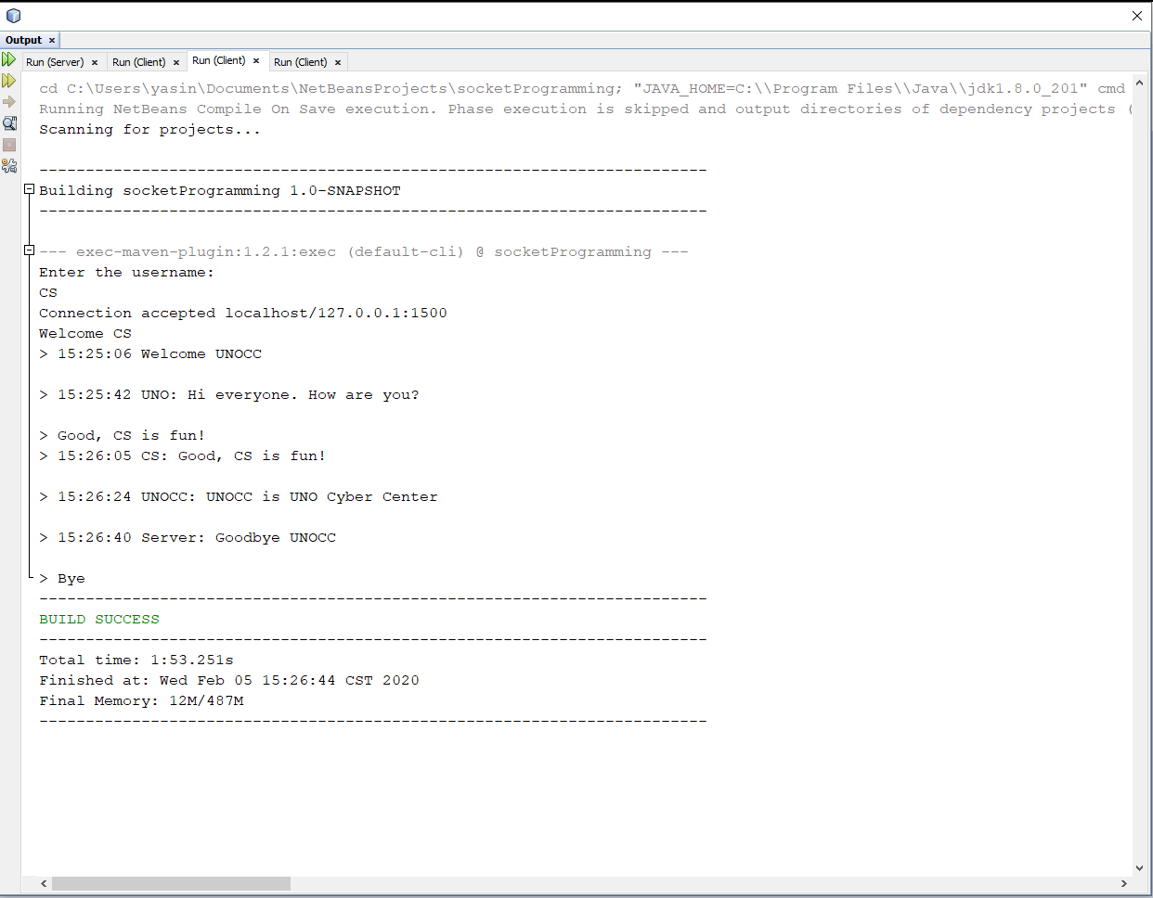

Client 3:

